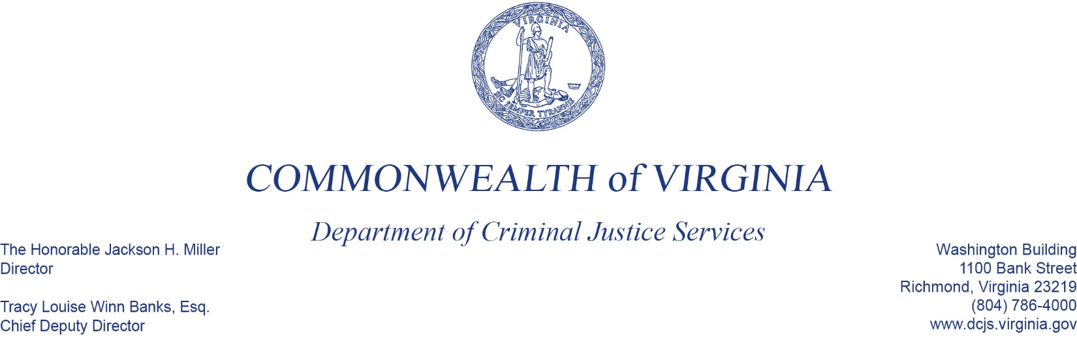
To: Criminal Justice Services Board Grants Committee
From: Donna Michaelis, Division Director, Virginia Center for School and Campus Safety
Date: June 2, 2022
Re: School Resource Officer/ School Security Officer Incentive Grant Program

You have before you the proposed budget for the School Resource Officer – School Security Officer Incentive Grant Program for FY23, totaling $4,444,510 in state funds for SROs and $392,715 for SSOs. This includes the funding of 60 continuation and 16 new grants, which funds a total of 86 SRO positions and 15 SSO positions in school divisions throughout the Commonwealth.
If approved, the grants can be awarded for a maximum period of 4 years (48 months), but reviewed annually for program compliance and budgeting. Continuation grantees will be funded for the balance of the 4 years, based on their current funding year.
This budget funds all of the eligible continuation grants and 16 out of 19 new applications. Two of the new applications were ineligible and one was incomplete. Another new application meets criteria at a reduced level because unallowable expenses were requested.
The proposed state budget states, “…the Department shall waive all matching requirements for grant recipients awarded funds the first year.” If this language is included in the budget signed by the Governor, we will ask CJSB approved applicants to revise their budgets accordingly.
Additional information:
- Not recommending:
  - Prince Edward (SRO)- ineligible
    - Supplanting Concerns: requested grant to help with funding for existing SROs.
  - Westmorland (SRO)- ineligible
    - Requested funding for the position that exceeded 4 years of grant funding.
  - Petersburg Public Schools (SRO & SSO)- incomplete application
    - Did not complete itemized budget sections (specifically Personnel and Employee Fringe Benefits) and unable to determine if request was allowable or reasonable.
    - Did not provide adequate information to determine a need.
    - Did not provide adequate information to determine if the application was for an SRO, SSO or both.
- Reduced:
  - South Boston- reduced level
    - Requested state funding for equipment, which is not allowed under the grant program.

